SAI Use Declaration Form
Course: Introduction to Artificial Intelligence
Lab Title: Lab 1 Part A — Uninformed Search Algorithms
Student Name: _____Samuel Asare Opong______________________________________________
Student ID: _____________01432028_________________________________________
GitHub Repository Link: ____https://github.com/SamuelOpong07/Opong_Samuel_Lab1.git_______________________________________
Date Submitted: ______20/06/2026____________________________________________

1. AI Use Summary
Question | Student Response
Did you use any AI tool for this lab? | Yes
Estimated percentage of the work influenced by AI | %10 – 15%
Did you attach evidence of AI use where applicable? | Yes

2. Details of AI Use
Complete the table below for each AI tool used. Add more rows where necessary.
Name of AI Tool Used | Purpose for Using the Tool | Prompt or Instruction Given to the Tool | Part(s) of the Work Influenced by the Tool | How I Verified, Edited, or Improved the AI Output
Claude | Debugging | Point out the issues with my code | The implementation | My code was able to run smoothly

3. Attachment of AI Output Evidence
Where required, attach evidence of AI use. Tick all that apply. Add more rows where necessary.
Evidence Type | Attached? (Yes, No, N/A) | File Name
AI-generated draft | No
Prompt history | No
Screenshot of AI interaction | Yes | 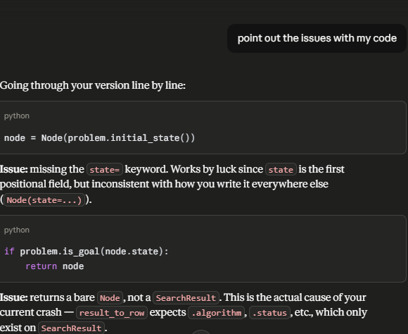
Exported AI conversation | No
AI-generated code snippet | No
Revised version showing student input | No

4. Student Declaration
I declare that:
Declaration Statement | Response (Yes/No)
The submitted work is my own work. | Yes
Any use of AI tools has been clearly declared in this form. | Yes
The prompts, instructions, and AI-generated outputs have been disclosed where applicable. | Yes
I reviewed, tested, edited, and improved any AI-generated content before submission. | Yes
My AI usage does not exceed 25% of the entire work. | Yes
I understand that undeclared or excessive AI use may be treated as academic misconduct. | Yes

Student Signature: ______________________S.A.O_____________________
Date: _______________________20/06/2026____________________

